**How Tesla Sets Itself Apart**

by

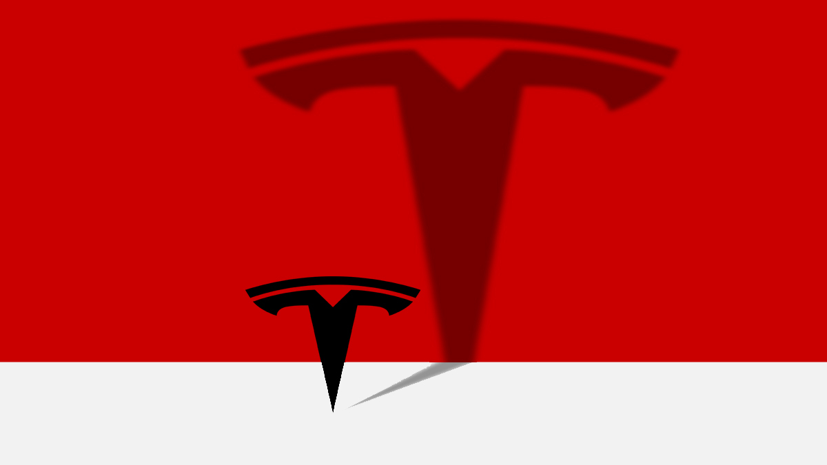HBR Staff

Tesla’s recent breakout market performance is proving some of its [skeptics](https://www.wsj.com/articles/tesla-careens-from-growth-story-to-demand-worries-11559564700) wrong. By mid-January, Tesla’s market capitalization had reached $107 billion, and it surged past the giant German automaker Volkswagen to become the world’s second most valuable auto company behind Toyota. Tesla’s valuation now [exceeds that of Ford and GM combined.](https://www.marketwatch.com/story/teslas-market-cap-is-now-bigger-than-fords-was-at-its-peak-2020-01-07)The Wall Street doubters may be in shock, but I’m not. Full disclosure, I own two Teslas and I own stock in the company. But it’s my experience as a three-time software company CEO that makes it increasingly clear to me that the company’s innovative business model represents an existential threat to the auto industry as a whole.How so?“Software is eating the world,” Marc Andreessen, co-founder and general partner of venture capital firm Andreessen Horowitz, wrote in a memorable 2011 essay. And software is a big part of Tesla’s advantage.

In my view, the traditional automakers are ill prepared to compete in today’s software-centered world. Unlike nimble Tesla, they are big, bureaucratic, slow to respond to customers, dependent on providing customer financing for unit sales growth, and culturally different from a software company.

And they know it. Last fall, the chairman of Volkswagen — still reeling from its auto-emission scandal — declared Tesla a [“serious competitor.”](https://electrek.co/2019/10/28/tesla-serious-competitor-vw-ceo-as-defends-electric-automaker/) The biggest challenge VW and other leading automakers face is that they lack the expertise required to compete in the age of the software car.  Tesla and its flamboyant, and sometimes [erratic](https://money.cnn.com/2018/09/08/news/companies/elon-musk-tesla-analysis/index.html), innovator Elon Musk have turned the more than a century old industry upside down in a mere 16 years.

How could the disruption have happened so quickly? The answer begins by looking at how the world’s traditional auto leaders got where they are today. What started as a fragmented market of some 200 car makers in the early 1920s gradually consolidated into a few behemoths who erected enormous, capital-intensive barriers to entry that they assumed to be unassailable.

Tesla’s speed in innovation in the market for high-end vehicles is more like a Google or an Amazon than an automaker. And its soaring market valuation is a clear sign to all automakers that they’ll need to develop more innovative, Tesla-like business models in order to survive.

As I see it, Tesla currently does at least four things better than all the auto makers:

**1. It develops cars as it would a software product.**

Tesla builds cars by developing software on unique hardware, much in the way Apple develops the iPhone or Microsoft leverages Intel chips and Dell PCs.  This enables the company to improve its cars’ software functionality every few weeks. This is in sharp contrast to the traditional auto industry model where the product is the same for as long as you drive it.

With fewer parts, [the total cost of Tesla ownership is significantly lower](https://cleantechnica.com/2019/06/12/tesla-model-3-maintenance-guide-costs-even-lower-than-i-thought/) than an internal combustion vehicle. There’s no need for expensive oil changes, tune ups, replacing mufflers, and the like. The automakers, who derive significant profitability from their service businesses, know this.

**2. It simplifies the buying process, putting the consumer in control.**

Tesla doesn’t advertise in the Sunday newspaper or put ads on the radio. Instead is uses the classic software “inbound” sales model: They know consumers are smart and will find them. They understand the buyers’ journey very well.

Buying a Tesla is relatively simple: You go online, pick a model, add your features, place your deposit, and schedule pickup. Done. The last time I bought a car from a well-known Japanese automaker, the buying process was miserable from start to finish. I had to talk to a sales rep who would not give me a straight price and kept scurrying back to a manager, who wrote down successive new numbers before we came to a deal. When I picked up the car, the salesperson begged me to give him a 10 on the Net Promoter Score survey so he could get his bonus. I much prefer controlling the experience myself.

**3. It leverages its prowess in battery technology to minimize the total cost of ownership over the vehicle’s lifetime.**

Tesla’s battery-powered vehicles are significantly simpler than their internal combustion competitors. By some estimates they have significantly fewer parts per vehicle — around 20 — versus the 2,000 in internal combustion engines. This simplicity dramatically reduces the consumers total cost of ownership. Tesla [has recently](https://www.engadget.com/2019/10/06/tesla-acquires-battery-expert-hibar/?guccounter=1&guce_referrer=aHR0cHM6Ly93d3cuZ29vZ2xlLmNvbS8&guce_referrer_sig=AQAAADOCFU8DuZOJrhSVQfGa9-5-cMP7_F2Q63azvFvqFGMMu9XfzBfqv0Cg-jQ3jxdWfwCwgKLYD_b4emthrG5XO0wlOoT1ALhuMloFoejBsmnyO2QCOTbBkmUaA4cMtGnd9mLiPMUnb0gUXBLv6_VniauKgdD4E22AIQWROLfIocmn) [acquired battery manufacturing companies](https://electrek.co/2019/10/05/tesla-quietly-acquires-battery-manufacturer/) and will incorporate new kinds of battery-related technologies into its vehicles, which could further reduce cost of ownership. While other automakers are also rushing to [acquire the right electric battery expertise](https://www.designnews.com/electronics-test/mainstream-automakers-embark-on-big-move-battery-electrics/94422093060984), they will still be playing catch up as this market grows.

**4. It attaches itself to the predominant market trend of the day — going green to reduce global warming.**

From a marketing point of view, Tesla already has a big advantage in some categories. Who wouldn’t want to own a car that [creates no pollution, eliminates visits to gas stations, and is truly green?](https://cleantechies.com/2011/05/25/top-ten-green-initiatives-from-global-automakers/) Other automakers are going to be playing catch up on this issue for a long time.

Given this situation, what is the auto industry to do? Traditional car makers will be offering a growing range [of electric vehicles in 2020](https://www.nytimes.com/2020/01/01/business/future-electric-cars-2020.html) — but they aren’t necessarily software cars. They are often the cars you’re used to, fitted with electric motors.

To be sure, there are [security risks](https://www.forbes.com/sites/daveywinder/2019/08/30/tesla-has-facepalm-moment-as-hackers-defeat-fixed-model-s-security/) with software cars, as with any kind of connectivity. But Tesla could expand its leadership role by modeling how to manage those risks effectively.

Traditional automakers must now imagine how to become software companies, which, given how far behind they are, means they will have to do what legacy software companies do when startups disrupt their core markets — they buy competitors to consolidate the market. We should watch for this activity, because it is likely about to start in earnest